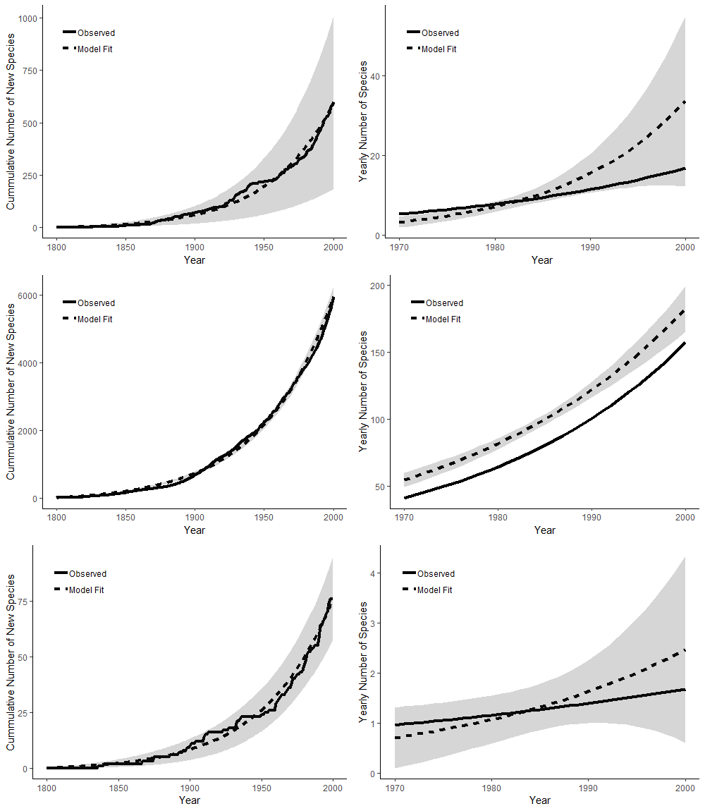

**Figure 1.** a-c: First records (solid) and Solow and Costello model fit (dashed) of birds (a), plants (b), and amphibians (c). d-f: Invasion rate as calculated by fitting an exponential model (solid) and Solow and Costello model accounting for detection rates (dashed) of birds (d), plants (e), and amphibians (f). Shaded area reflect Solow and Costello model 95% CI.